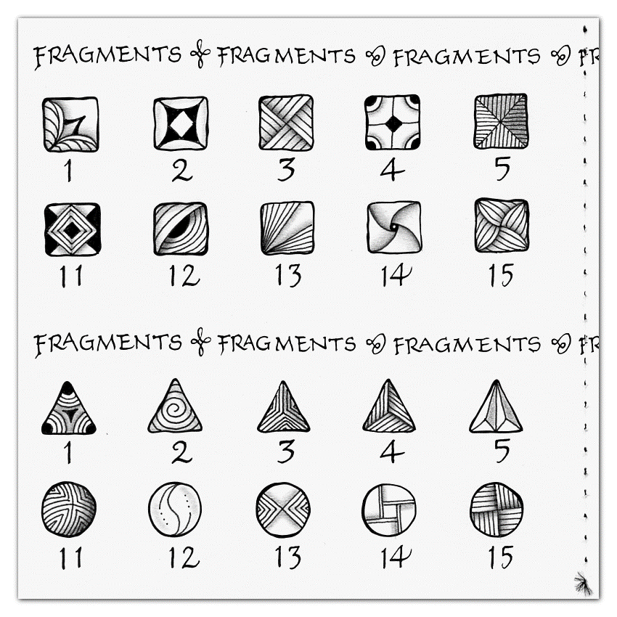
Zen Button Template and fragment ideas from Zentangle Project Pack 10, Day 8

